EXPLORE THE WORLD WITH SHEAFE’S FLAT BLUEBIRD
Due: Friday, February 10, 2012

STUDENT NAME: ___________________________________________________ ROOM _____________

This month, Sheafe’s Flat Bluebird leaves the COOL continent of Antarctica to fly north to the continent of Asia! We fly from the continent with the smallest population to the one with the largest! Asia has almost 4 billion people!
Asia is the largest continent in the world, stretching into two hemispheres. Did you know that the prefix “hemi” means half? A hemisphere is half of a sphere. Asia is so large it spans the Northern Hemisphere and the Eastern Hemisphere. It is made up of 44 countries and islands. The largest countries are China, India and Russia. On the map below, color China red, India yellow, and Russia green.
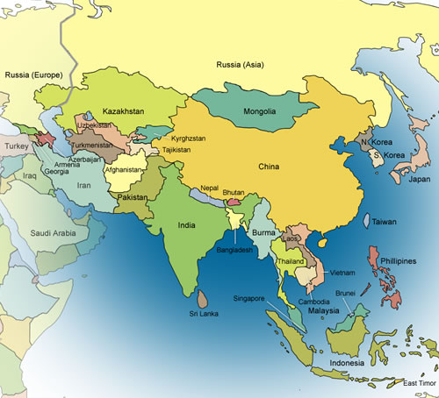
Looking for more of a challenge… turn the page over!

Asia includes the highest point in the world. The tallest mountain, Mt. Everest, is 29, 035 feet above sea level. It is between the countries of China and Nepal.
Asia also contains also the world’s lowest point, the Dead Sea, which is located within Israel and Jordan. It is 1,286 feet below sea level.
Find the difference in feet between the highest point in the world and the lowest. SHOW YOUR WORK!

Answer: __________________________

What continent is directly west of Asia? _______________________________

What continent is southwest of Asia? _________________________________

Asia is surrounded on 3 sides by oceans.

Tell which ocean is north of Asia. ______________________________ Ocean

Tell which ocean is south of Asia. ______________________________ Ocean

Tell which ocean is east of Asia. ______________________________ Ocean

